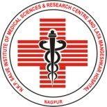 | N.K.P. Salve Institute of Medical Sciences & Research Centre and  Lata Mangeshkar Hospital  Digdoh Hills, Hingna Road, Nagpur – 440 019 | 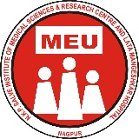
Phone (07104) 665000,244291, Fax:(07104) 306111- mail: nkpsims1@rediffmail.com/website : www.nkpsims.in

NKPSIMS & RC and LMH/ MEU/ / 2025 Date: 29th Oct 2025

Medical Education Unit
Report on Orientation and Demonstration of Basic Life Support (BLS)
An orientation and demonstration session on Basic Life Support (BLS) was conducted for the First MBBS 2025 batch on 29th October 2025. The session was attended by 151 students and was coordinated by the Medical Education Unit (MEU) of the college.

The session was led by Dr. Anjali Bhure, Professor and Head, Department of Anaesthesiology, along with Dr. Shilpa Deoke, Professor, Department of Medicine, and Dr. Prerna Agrawal, Assistant Professor, Department of Anaesthesiology. The objective was to orient students to the fundamental concepts of life-saving measures and the importance of immediate response during medical emergencies.

Through live demonstrations and videos, the faculty illustrated the steps of cardiopulmonary resuscitation (CPR), airway management, chest compressions, and use of an automated external defibrillator (AED). Emphasis was placed on the “chain of survival” and teamwork during emergency situations.

Students actively participated in the hands-on demonstration, gaining awareness of the practical aspects of resuscitation techniques. The interactive nature of the session enhanced understanding and confidence among students.

The program was highly appreciated for its relevance and clarity. It successfully introduced future medical professionals to essential emergency response skills, marking an important component of their foundation course.
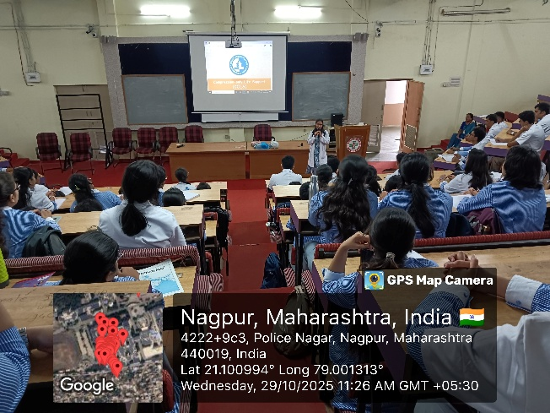

Dr. Madhur Gupta
Director MEU
NKP SIMS & RC and LMH

