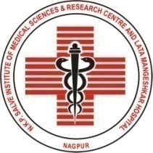 | N.K.P. Salve Institute of Medical Sciences & Research Centre and  Lata Mangeshkar Hospital  Digdoh Hills, Hingna Road, Nagpur – 440 019
Phone (07104) 665000,244291, Fax:(07104) 306111- mail: nkpsims1@rediffmail.com/website : www.nkpsims.in
No.NKP&LMH/Radiology/ 246 /2025 Date : 26/09/2025

DEPARTMENT OF RADIODIAGNOSIS

GUEST LECTURE ON CASE BASED DISCUSSION

Organized by Department of Radiodiagnosis NKPSIMS on 25TH SEPTEMBER (9.30 AM to 10:30 AM)

Guest speaker:Dr. Dhanashree Dande Rajderkar ,

Dhanashree Dande Rajderkar is a renowned faculty with expertise in Radiology currently licensed in India, Florida and Missouri. Ma’am conducted series of interactive lectures on topics of cases important in exams. Ma’am discussed various cases in imaging of common pathologies.

All the PG students of Dept of Radiology attended this lecture.

