NKPSIMS & RC and LMH/ GGC/ / 2025 Date: - 22/09/2025

**GENDER GRIEVANCE COMMITTEE**

**Guest Lecture on POSH Act on Friday 19/09/2025**

The Gender Grievance Committee organised a guest lecture on POSH ACT by Dr. Disha Methwani, LLB and Lecturer ENT, NKPSIMS & RC and LMH. Dr. Disha explained the various parts of the act in a very simplified way to the audience. The lecture sensitized all present to the nights of women when they feel sexually harassed. The audience interacted and asked their queries regarding POSH Act.

The informative talk was highly appreciated by an audience of 104 staff members including teaching staff, nursing staff and non teaching staff. .

Following the lecture all ladies were given a female hygiene kit by the Proctor and gamble company.

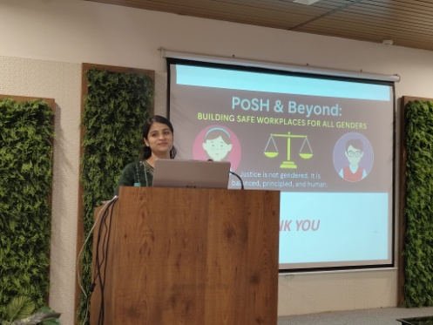 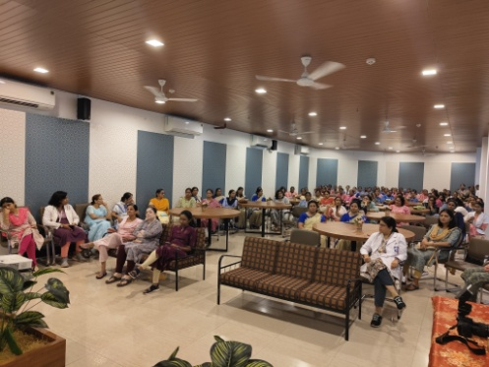 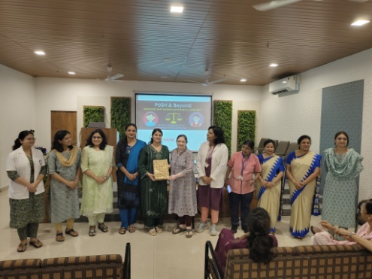

**Dr. Kanchan Dhote Dr. Anne Wilkinson**

**Asso. Professor, ENT Professor, Pathology**

**Secretary GGC/ICC Chairperson GGC/ICC**